**Local DNS Attack SEED Lab**



**Local DNS Attack SEED Lab**

**Main Introduction:**

DNS is the Internet's phone book. it translates hostnames to IP addresses and vice versa. This translation is through DNS resolution, which happens behind the scenes. This lab focuses on several DNS attack techniques. We will set up and configure a DNS server, and then try various DNS attacks on the target.

In this lab, we will do the following:

* Set up DNS server.
* DNS cache poisoning
* Spoofing DNS responses
* Use Scapy and Netwox

**Network physical topology:**

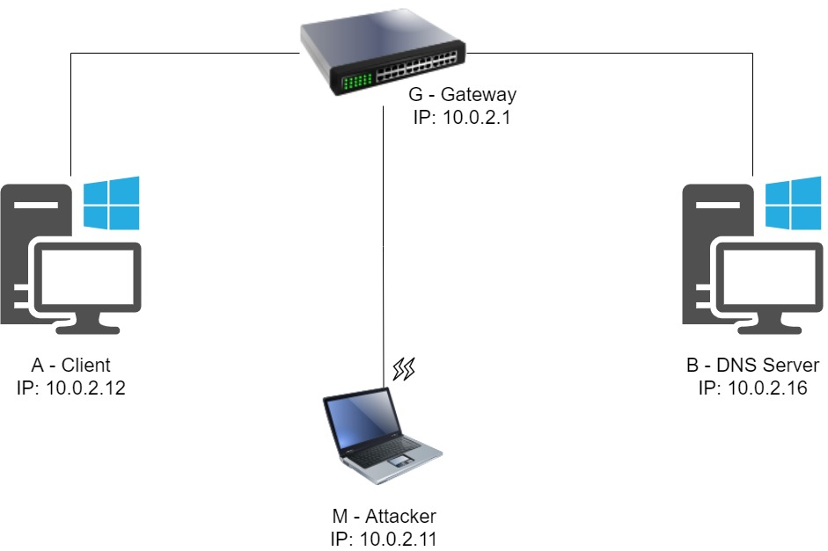

**Task 1: Configure the User Machine**

**Task Description:**

We need to configure the DNS server on the client A (10.0.2.12)

We can see the dns servers before making any changes.

Both google and one.one.one.one dns server.

I added the 10.0.2.16 server to /etc/resolvconf/resolv.conf.d/head.

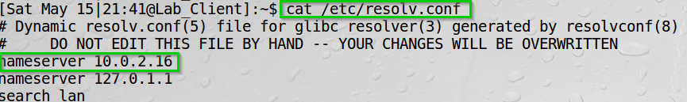We can see the resolv.conf file content.

The nameserver is updated.

I ran “sudo resolvconf -u” so the changes take place.

We can see no errors.

And we can see a successful output of the dig command.

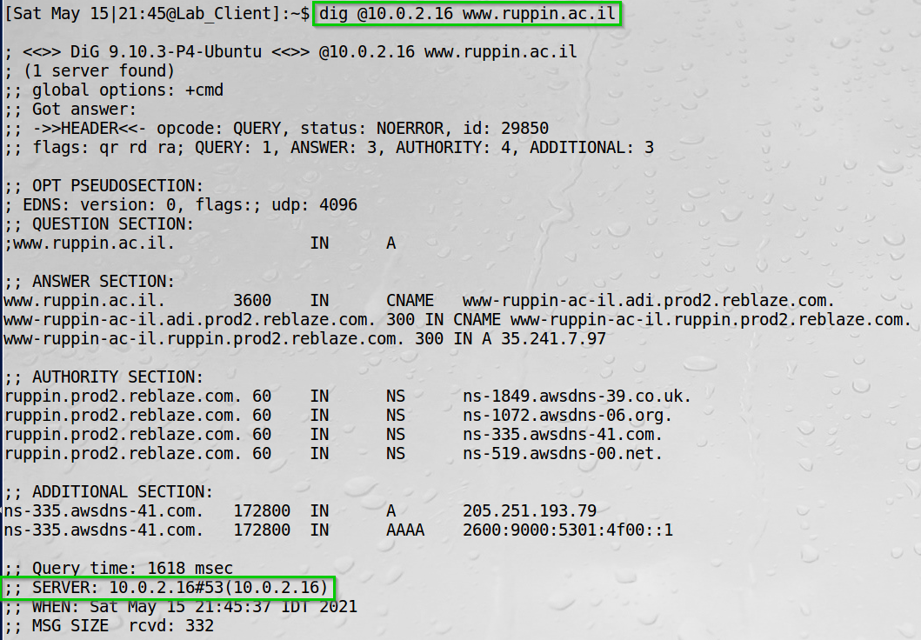The ‘@’ specify which server to use for the resolution.

We can see the output came from the 10.0.2.16 server.

**Task 1 Summary**

* I have learned how to configure DNS server for a client.
* I also learned use of the ‘dig’ command.

**Task 2 + 3: Set up a Local DNS Server and host a DNS zone**

**Task Description:**

We will configure the BIND9 server.

We will check our work by pinging and viewing Wireshark traffic.

We will host a DNS zone in our local DNS server.

In /etc/bind/named.conf.options I added the entry:

options {

dump-file "/var/cache/bind/dump.db";

};

In /etc/bind/named.conf.options

I edited the option as such:

options {

# dnssec-validation auto;

dnssec-enable no;

};

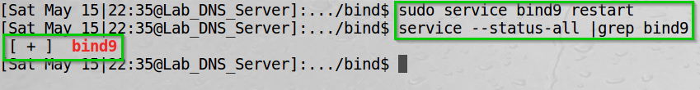Then restarted the bind9 service:

We can see the service is running.

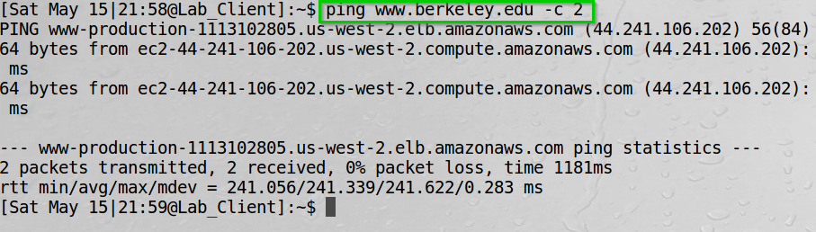Then I pinged Berkley university website.

The ping was successful.

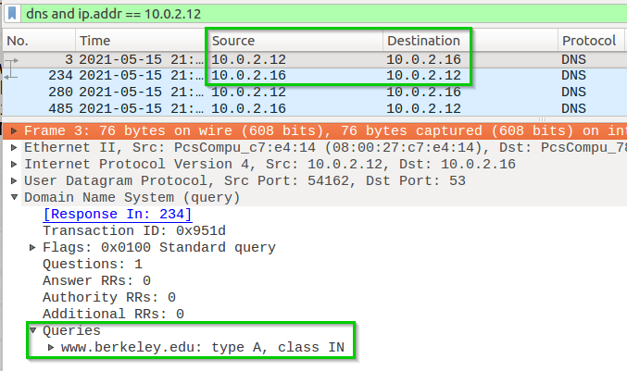Wireshark view.

We can see our DNS query resolved by our DNS server 10.0.2.16.

Then I edited the /etc/bind/named.conf file to specify dns zones:

zone "example.com" {

type master;

file "/etc/bind/example.com.db";

};

zone "0.168.192.in-addr.arpa" {

type master;

file "/etc/bind/192.168.0.db";

};

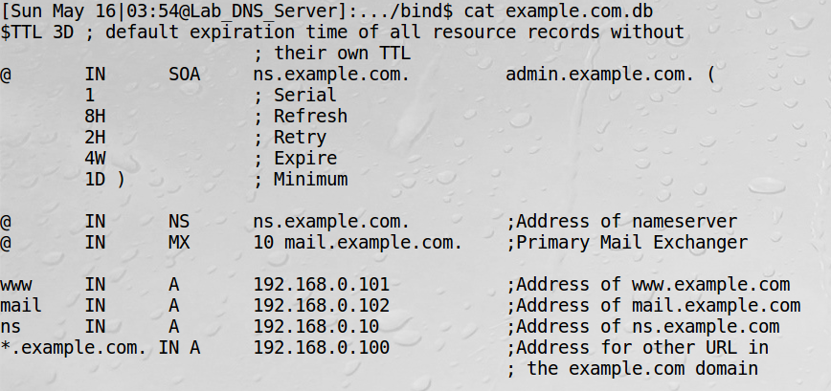Set up our forward lookup zone in the example.com.db file:

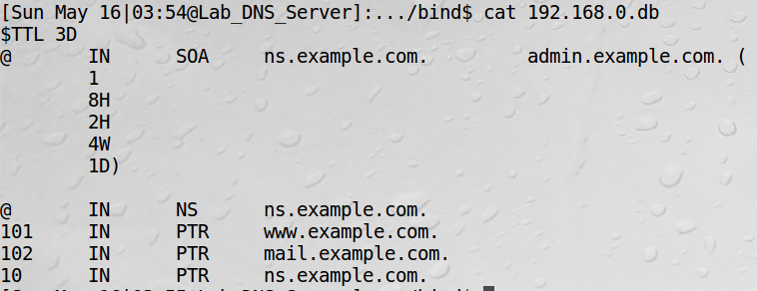Set up our reverse lookup zone in the 192.168.0.db file:

Then I again restarted the bind9 service

We can see the service is running.

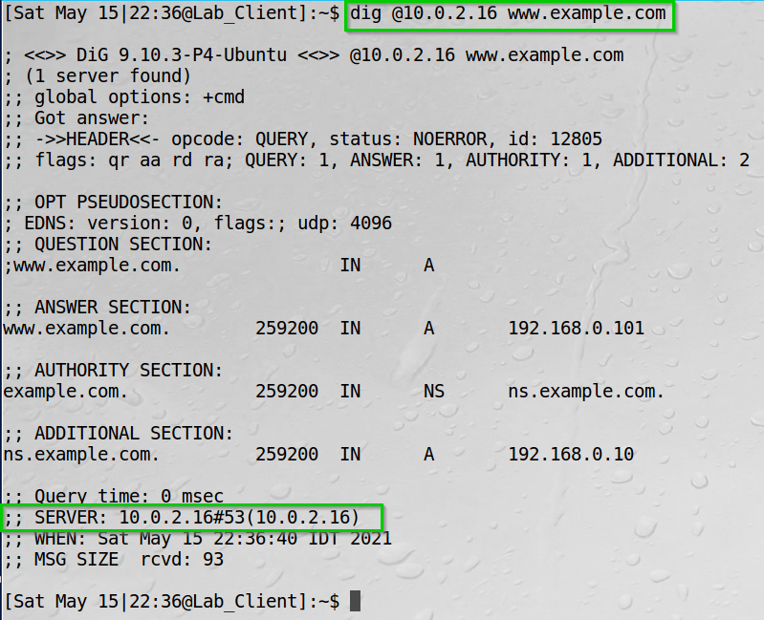Using the ‘dig’ command I checked our example DNS zone is active.

We can see we got an answer from our DNS server 10.0.2.16

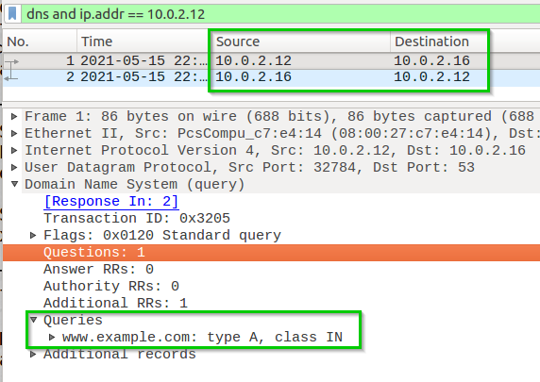Wireshark view

We can see the question goes to 10.0.2.16

**Task 2+3 Summary**

* I have learned about the BIND9 server.
* I have learned about DNS zones.
* I have learned how to dump and view the DNS cache.
* I configured the zones files for our example.com zone.

**Task 4: Modifying the Host File**

**Task Description:**

The hosts file is a file where the operating system checks for DNS resolution even before it checks its own DNS cache.

I changed the client’s hosts file to translate www.example.net to our attacker ip.

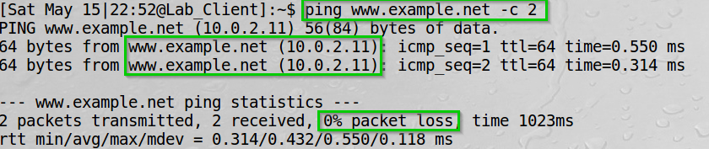I then ping www.example.net.

We can see we get an answer from our attacker 10.0.2.11.

**NOTE:** The “attack” as instructed was made by us changing the hosts file.

In a more realistic situation, we would probably conduct an attack telnet or Netcat and send a command to add ourselves to the hosts file.

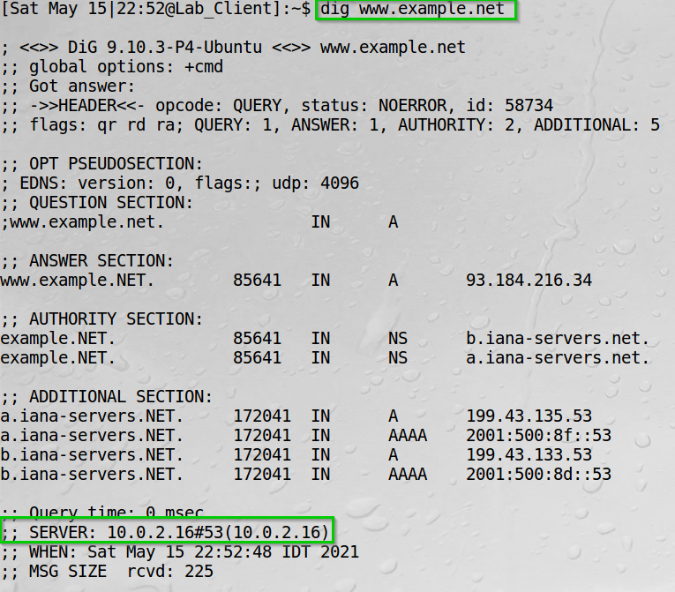Viewing the dig command output

We can see there was no effect when using the dig command, since it ignores the hosts file.

**Task 4 summary**

* I have added an entry to the hosts file.
* I watched the ping being sent to our attacker instead of the DNS server.

**Task 5: Directly Spoofing Response to User**

**Task description:**

I will send a DNS reply from the attacker to the client after the client send a request.

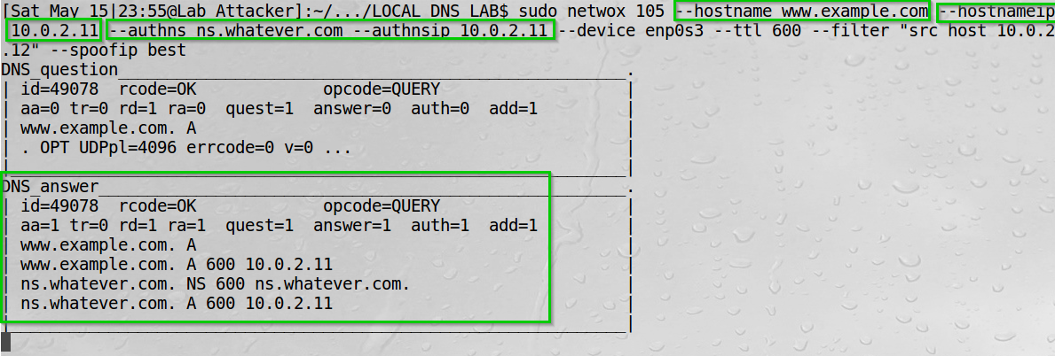Using Netwox I conducted the DNS reply attack.

We can see here the question and answer being sent (This happens after the dig command below).

Used the dig command from the client.

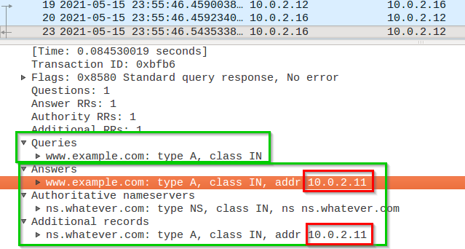By viewing Wireshark, we can see our DNS reply sent.

We can see our DNS reply. Unfortunately, no matter how many times we have tried, the DNS server answered before we could.

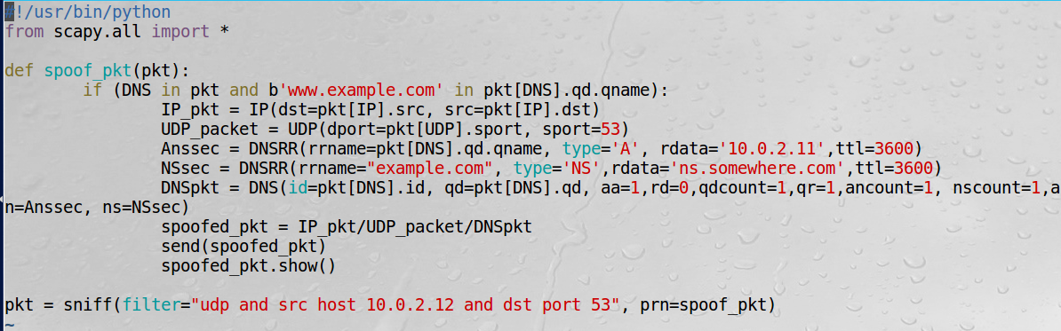I also tried conducting the attack using Scapy.

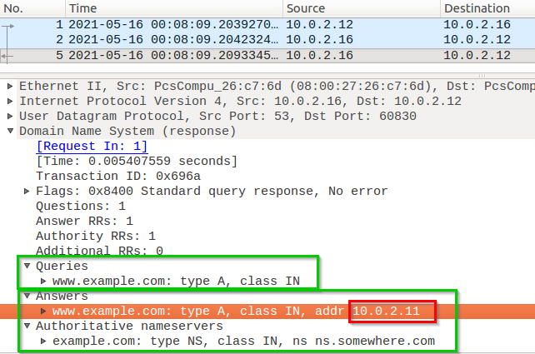Again, by viewing Wireshark we can see our DNS answer.

We can see again we could not answer faster than the DNS server.

**Task 5 Summary**

* I have learned how to use the netwox 105 tool – sniff and send DNS answers.
* I have learned how to construct a DNS answer using Scapy.
* I failed answering faster than the DNS server.
* On a lookback I might have succeed if I use “- -spoofip raw”

**Task 6: DNS Cache Poisoning Attack**

**Task description:**

I will conduct a DNS cache poisoning attack.  
Instead of attacking the client we now attack the server itself, so no matter who send a DNS query for the example.net would reach us.

I used Netwox to attack the DNS server.

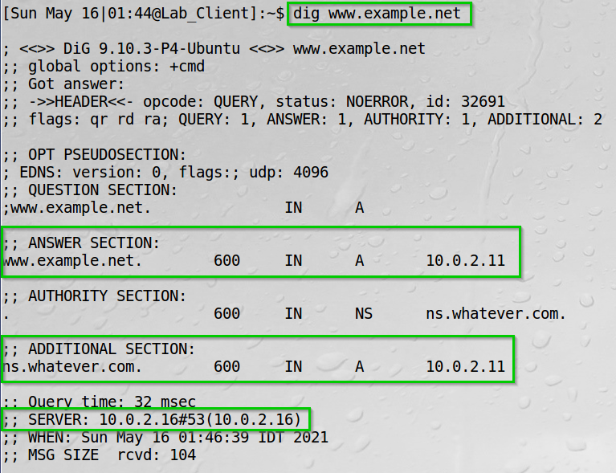Ran the dig command.

We can see we got an answer from 10.0.2.16 about the example.net destination and the answer sends us to 10.0.2.11

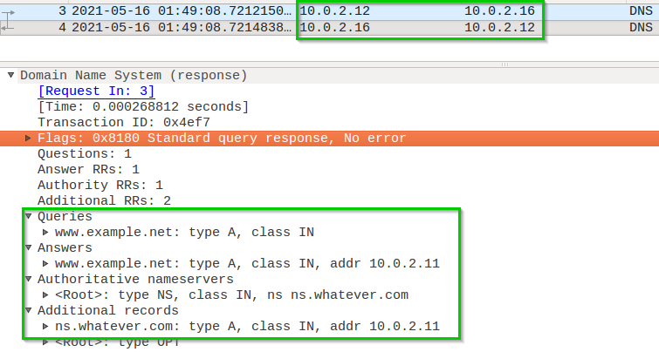We can view it in Wireshark.

We can see our query for www.example.net.  
We can see our answer for www.example.net at 10.0.2.11.  
We can also see our additional record for ns.whatever.com at 10.0.2.11.

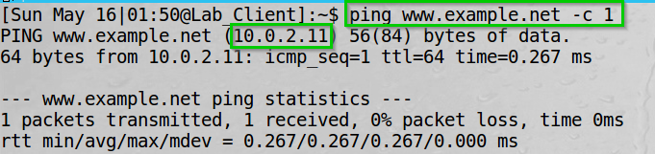  
We can now try and ping www.example.net.

We can see we got a reply from 10.0.2.11.

**Task 6 Summary**

* I have learned how to use the netwox 105 tool – sniff and send DNS answers.
* I managed to send our answer to the client.
* I used the “- -spoofip raw” so I did not have to waste time conducting an arp attack (being conducted by Netwox 105 otherwise specified)

**Task 7: DNS Cache Poisoning: Targeting the Authority Section**

**Task description:**

I will conduct a DNS cache poisoning attack – now targeting the Authority section.  
Now we want that any query to the example.net. will reach us.   
Such as the mail.example.net.

First, flush the DNS cache on the server.

We can see no errors.

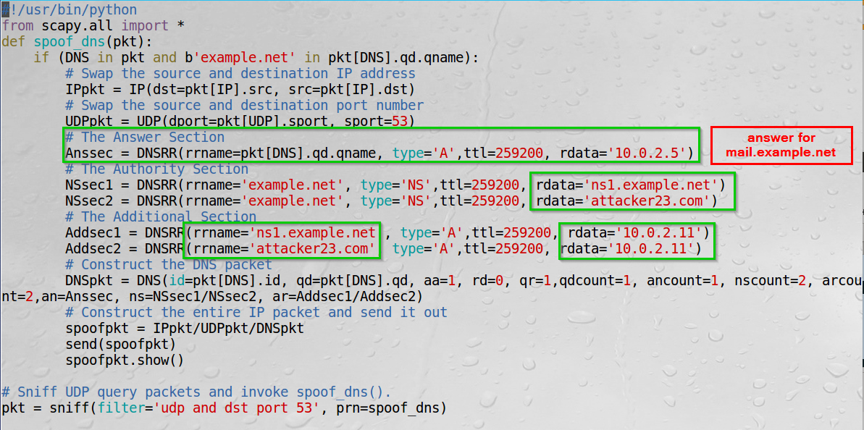I conducted the DNS answer using Scapy.

Specify that the answer would be in 10.0.2.5

Also send Authority answer specifying 2 records.

Also add Additional records.

I ran my script.

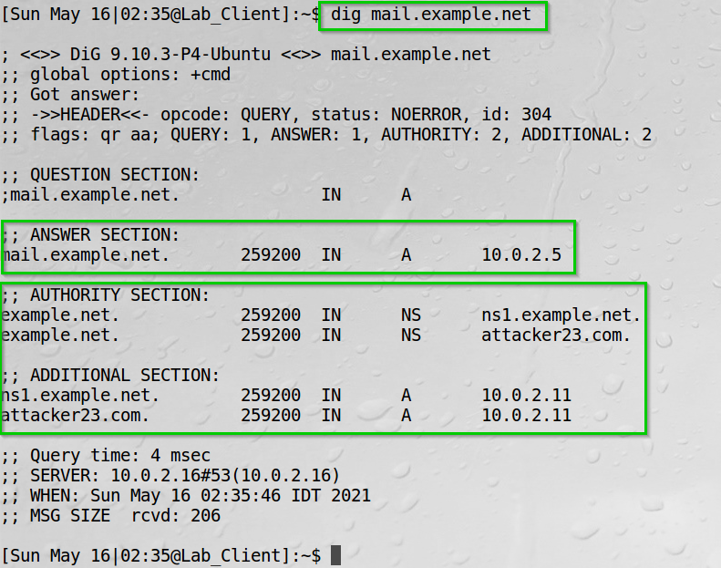Ran the dig command.

We can see the answer, authority, and additional sections.  
We can see the mail.example.net answer at 10.0.2.5.

**Task 7 Summary**

* I have learned how to conduct DNS answer with NS (authority) records and Additional section.
* I started my attack. The client used the dig command creating a DNS query cached by our script.
* We sent the answer with our additional data.
* We finally viewed our formed attack on the client.

**Task 8: Targeting Another Domain**

**Task description:**

I will conduct a DNS cache poisoning attack – now targeting the Authority section – adding another domain.

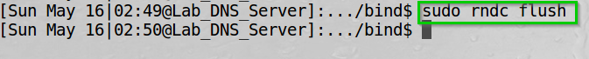Flushed the server DNS cache.

We can see no errors.

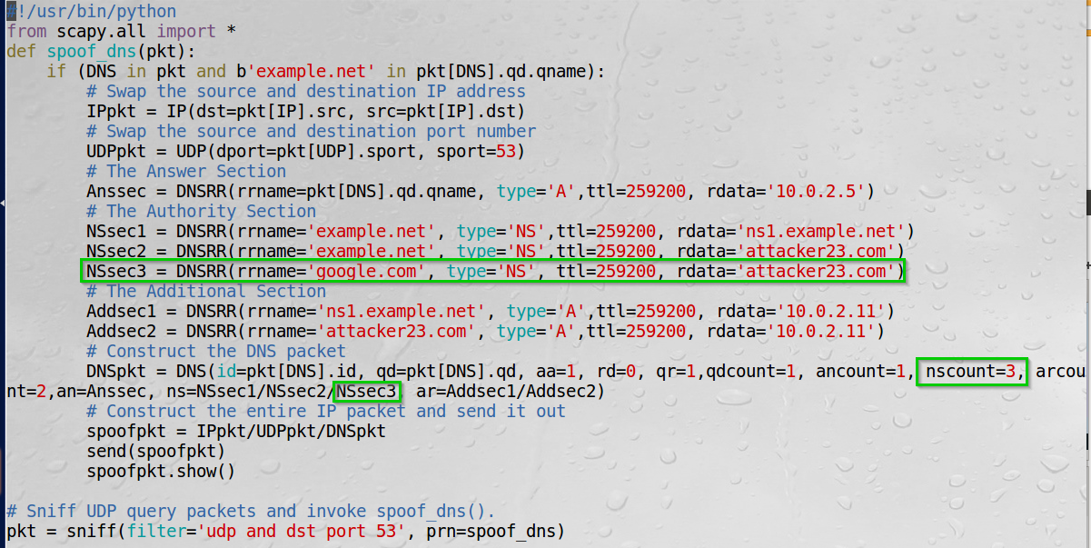I wrote the following script.

We can see we added the google.com NS record, changed the nscount and concatenated the SNsec3 to our ns.

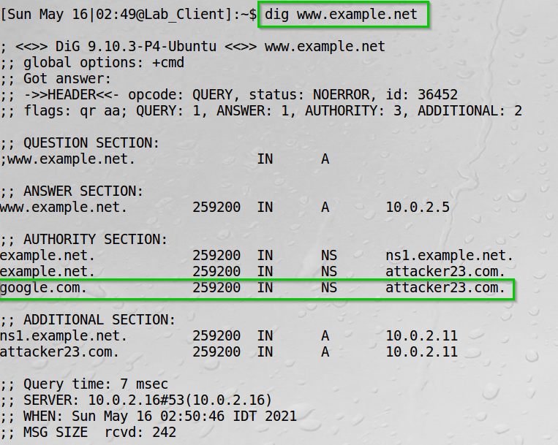Ran my script on the attacker and then ran the dig command on the client.

We can see the Authority answer added to the Authority section.

**Task 8 Summary**

* I have learned how to conduct DNS answer with NS (authority) record.
* I started our attack. The client used the dig command creating a DNS query cached by our script.
* We sent the answer with our additional data.

**Task 9: Targeting the Additional Section**

**Task description:**

I will conduct a DNS cache poisoning attack – now targeting the Authority section – adding another domain.

Flushed the server DNS cache.

We can see no errors.

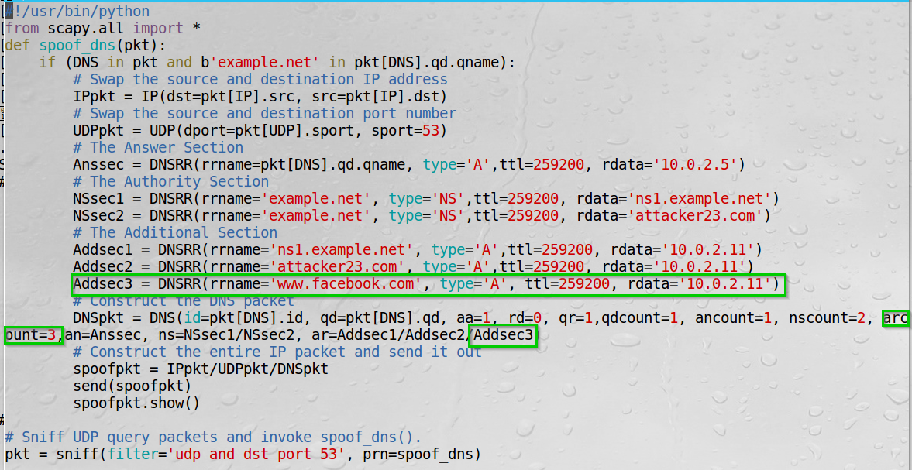I wrote the following script.

I added an additional record for www.facebook.com, set the arcount to 3 and concatenated the Addsec3 to our ar.

Ran my script.

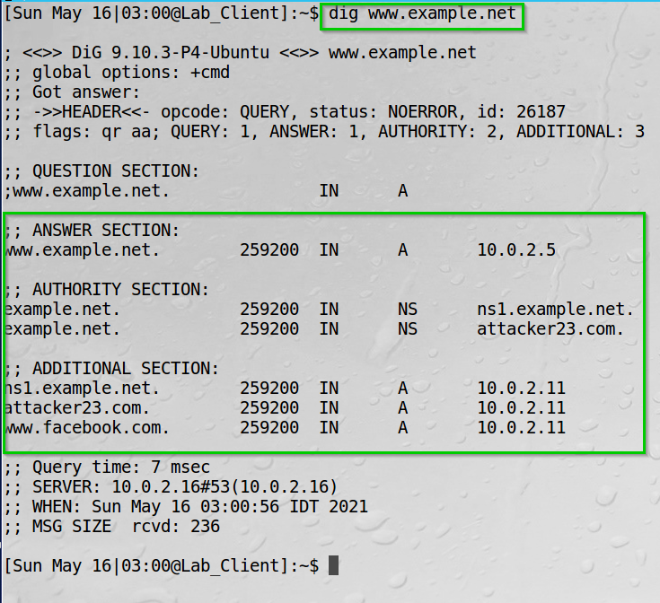Ran the dig command on the client.

We can see the www.facbook.com added to the additional section.

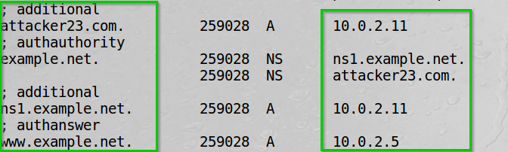When checking the dump file, we cannot see the facebook.com record.



**Task 9 Summary**

* I have learned how to conduct DNS answer with AR (additional) record.
* I started our attack. The client used the dig command creating a DNS query cached by our script.
* We sent the answer with our additional data.
* We could see the additional section was not reflected in the server dump cache file.

**Lab Summary**

**Task 1:** I configured the DNS server on the client A.

**Task 2 + 3:** I configured the BIND9 server.

I hosted a DNS zone in our local DNS server.

**Task 4:** I edited the hosts file. By doing so, the OS found the attacker’s ip as a translation for the example.net host -> therefore pinging the attacker instead.

**Task 5:** I tried spoof and respond a DNS answer to the client however I filed.

**Task 6:** I learned how to use the netwox 105 tool – sniff and send DNS answers I sent our answer to the client.

**Task 7:** I used Scapy to conduct the DNS cache attack, targeting the Authority section. Basically, adding a line of code specifying an NS record to be sent to the victim.

**Task 8:** I used Scapy to conduct the DNS cache attack, targeting another section. Basically, adding a line of code specifying an NS record to be sent to the victim.

**Task 9:** I used Scapy to conduct the DNS cache attack, targeting the Additional section. Basically, adding a line of code specifying an Additional record to be sent to the victim.

The last record added (Facebook) was not related to hostnames in the Authority section.